Comparative Analysis of Pneumonia Detection Models
Our Proposed DenseNet-121 Model vs. Five Previous Research Models

Comparative Analysis Table

Aspect | VGG16 | ResNet50 | InceptionV3 | EfficientNet | CNN + Transformer | Our Model
Main Architecture | VGG16 CNN | ResNet50 CNN | InceptionV3 CNN | EfficientNet | CNN + Transformer | DenseNet121
Feature Extraction | Convolutional layers | Residual blocks | Inception blocks | Efficient feature blocks | Multiple CNN features | DenseNet121
Classification | Pneumonia / Normal | Pneumonia / Normal | Pneumonia / Normal | Pneumonia / Normal | Binary / Multiclass | Normal / Pneumonia
Explainability | Limited | Limited | Limited | Limited | Visual saliency maps | Grad-CAM heatmap
Confidence Output | Prediction | Prediction | Prediction | Prediction | Classification result | Prediction + confidence
Pipeline | Standard CNN | Standard CNN | Standard CNN | Efficient CNN | Complex hybrid | Lightweight pipeline
Output | Classification | Classification | Classification | Classification | Classification + explanation | Classification + confidence + heatmap

2. Our Proposed Model – Measured Results
Metric | DenseNet-121 (Our Implementation)
Accuracy | 84.13%
Precision | 89.86%
Recall | 84.10%
F1-Score | 86.89%
ROC-AUC | 91.89%
Test Images | 624

3. Comparative Accuracy Graph
The graph below compares the accuracy reported by five previous research approaches with the accuracy measured in our DenseNet-121 implementation.
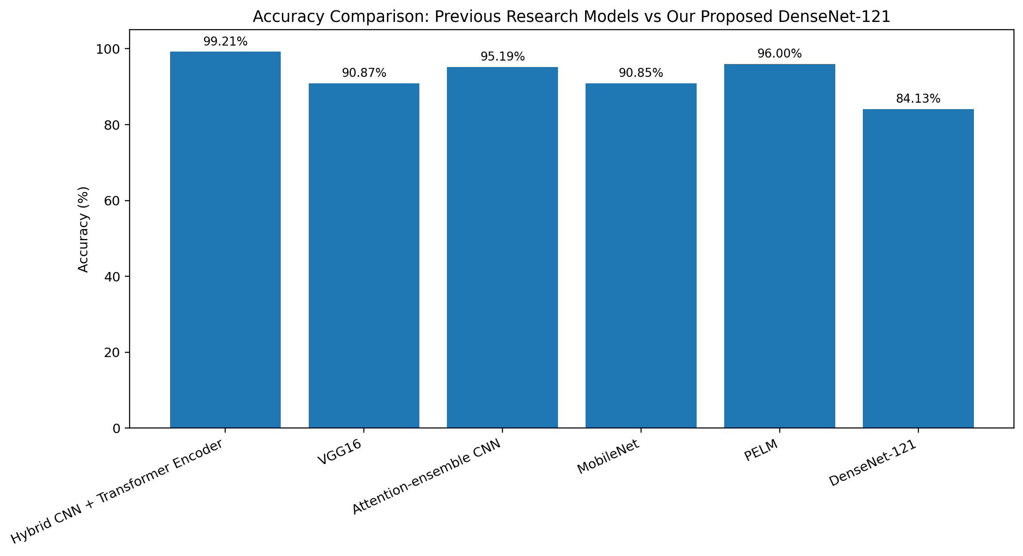
Interpretation: our current DenseNet-121 implementation achieved 84.13% accuracy on our test set. The graph does not establish that our model is universally better or worse than the published models, because the experiments were performed under different conditions. A controlled five-model experiment on the same dataset and test split would be required for a direct performance ranking.

4. How Our Model Differs
- DenseNet-121 transfer learning is used as the core classifier.
- Grad-CAM is integrated to visualize image regions that contributed to the model prediction.
- The prototype provides an image-level prediction confidence score.
- The model is exposed through a FastAPI prototype for local demonstration.
- The implementation is developed and executed in VS Code using PyTorch.

5. Research Sources Used for the Literature Comparison
- Ukwuoma et al. (2023), “A hybrid explainable ensemble transformer encoder for pneumonia identification from chest X-ray images.” Reported 99.21% binary classification accuracy and F1-score.
- IEEE (2024), “Optimizing Chest X-ray Analysis for Pneumonia Detection Through Comparative Evaluation of Transfer Learning CNN Architectures.” Reported 90.87% accuracy for VGG16 in the study.
- Diagnostics (2024), “A Deep Convolutional Neural Network for Pneumonia Detection in X-ray Images with Attention Ensemble.” Reported 95.19% accuracy for its proposed attention-ensemble model.
- Healthcare (2023), “Detection of Pneumonia from Chest X-ray Images Utilizing MobileNet Model.” Reported 90.85% accuracy for MobileNet on the reported dataset.
- Applied Sciences (2025), “PELM: A Deep Learning Model for Early Detection of Pneumonia in Chest Radiography.” Reported 96% accuracy for PELM.
For the final research paper, the bibliography should be formatted according to the citation style required by your department/conference (for example, IEEE).

